**Five Project Phases:**

Initiating

Planning

Executing

Monitoring & Controlling

Closing

**Initiating:**

Project charter

Business case

High level scope definition

High level risks

Stakeholder register

**Planning:**

Schedule

Scope management plan

WBS (Work Breakdown Structure)

Scope baseline

Detailed risks

Requirements management plan

Change management plan

Budget

**Executing:**

Project deliverables (unique work packages defined in the WBS)

**Monitoring & Controlling:**

Issues log

Performance measurement & reporting

QA/governance

Change control

Budget

**Closing:**

Transition/integration plan

Project sign off

Archiving project documents

Lessons learned

Releasing resources

Closing contracts

**Cost Calculations (Page 52):**

Planned Value (PV) = (planned % complete) x budget

Earned Value (EV) = (% of completed work) x budget

Actual Cost (AC) = the money actually spent to date, no formula, just add the costs up

**Earned Value Management (EVM):**

Schedule Variance (SV) = difference between the PV and EV

Cost Variance (CV) = budget deficit or surplus at any given point in time

Schedule Performance Index (SPI) = ratio of EV to PV

Cost Performance Index (CPI) = ratio of EV to AC (Actual Cost)

Burn rate = 1 / CPI

**Forecasting Calculations:**

Estimate At Completion (EAC) using Estimate To Complete (ETC) = AC + ETC

EAC for work performed at current rate = AC + (budget – EV)

EAC for work performed at current CPI = Budget / CPI

EAC for work including both CPI & SPI = AC + ((bedget – EV) / (CPI x SPI))

To-Complete Performance Index (TCPI):

TCPI using current budget = (Budget – EV) / (Budget – AC)

TCPI using EAC = (Budget – EV) / (EAC – AC)

**Constraints:**

Triple Constraint:

Cost

Scope

Time

**All constraints:**

Cost

Scope

Time & scheduling

Deliverables

Quality

Environment

Resources

Requirements

**Project Influences:**

Change requests

Scope creep

Constraint reprioritization

Interaction between constraints

Stakeholder/sponsor/management influences

Influence by other projects

**Risk Identification:**

Brainstorming: facilitator helps obtain a list of project risks

Interviewing: encourage team members, stakeholders, & SMEs to ID risks

Root-cause analysis: ID causes that led to problems, then develop preventive actions

Delphi technique: develop a risk list based on expert opinion

**Risk Strategies:**

Accept:

Mitigate:

Transfer:

Avoid:

Exploit: ensuring a positive risk occurs

Enhance: ID key drivers of a positive risk, then adjust them to increase probability

Share: strategy for positive risks whereby partial ownership is allocated to a third party

**Creating the Project Schedule:**

1. Determine the tasks
2. Determine the project’s milestones
3. Determine each task’s durations and start/finish dates
4. Set predecessors and dependencies
5. Sequence and prioritize the tasks
6. Determine the critical path
7. Allocate project resources to the individual tasks
8. Set he schedule baseline
9. Set the quality gates
10. Set the governance gates

**Team Building:**

Forming: team meets, trust is not yet built

Storming: team starts making decisions about the project, vying for position, confrontational

Norming: team starts working together, trust begins

Performing: team starts working as a unit

Adjourning: team completes the project

**Conflict Resolution:**

Smoothing: aka accommodating, emphasizes areas of agreement

Forcing: manager dictates the COA

Compromising: aka reconciling, both parties agree

Confronting: aka problem solving, uses multiple viewpoints to lead to consensus

Avoiding: aka withdrawing, postpones the issue

Negotiating: basically compromising with a mediator

**Change Control Process:**

1. Identify & document the change
2. Evaluate the impact of the change and provide justification for it
3. Develop a regression plan in case the change needs reversed
4. Identify the change approval authority
5. Obtain approval for the change
6. Implement the change
7. Validate the change and check the effect on quality
8. Update project documents, audit, implement version control

**Charts:**

**Process diagram/flowchart/network diagram:** sequential breakdown of required steps, shows relationships. Used to sequence activities (Sybex page 99).

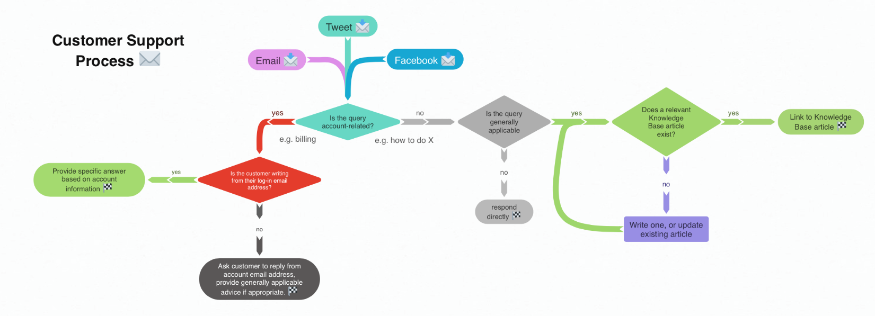

**Precedence Diagramming Method:** uses boxes, referred to as nodes, to represent activities and connects them with arrows that show the [dependencies](https://en.wikipedia.org/wiki/Dependency_(project_management))

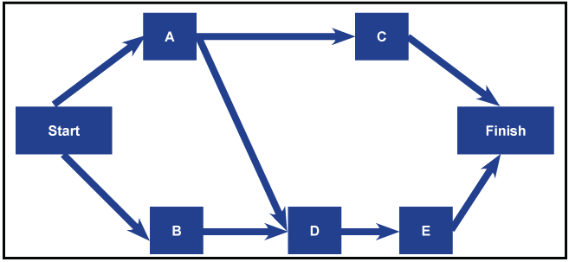

**Arrow Diagramming Method:** Precedence relationships between activities are represented by circles connected by one or more arrows. The length of the arrow represents the duration of the relevant activity. ADM only shows finish-to-start relationships, meaning that each activity is completed before the successor activity starts.

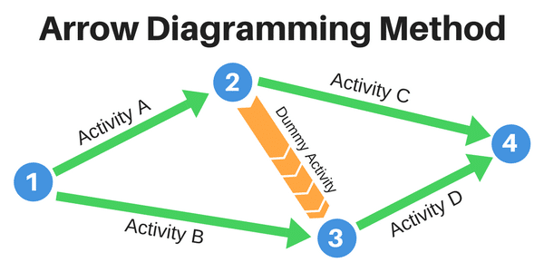

**Histogram:** specialized bar graph, primarily used to depict the approximate distribution of statistical data

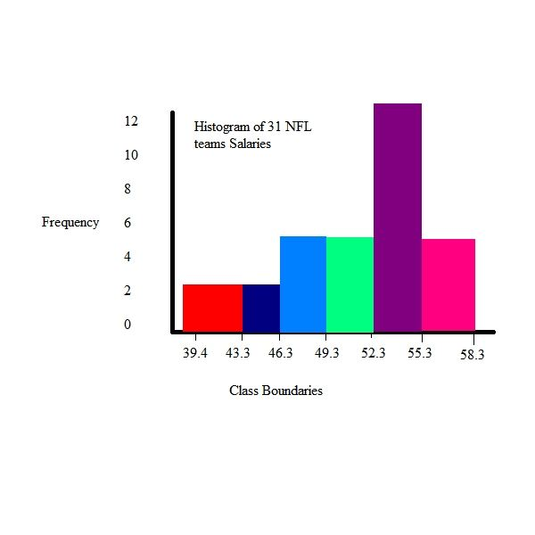

**Fishbone/Ishikawa diagram:** used to ID root causes

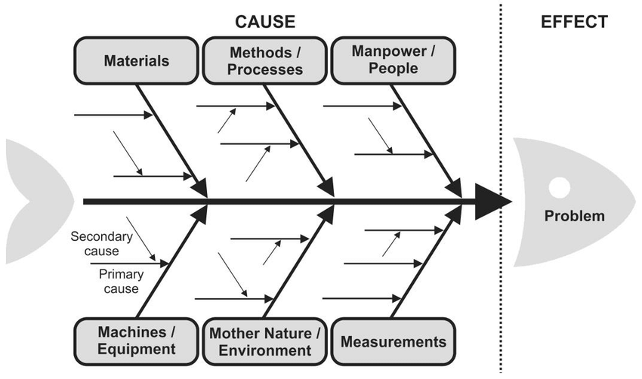

**Pareto chart:** used to set priorities for QA, most often used in conjunction with fishbone diagrams

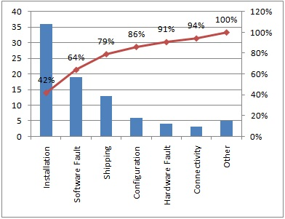

**Run chart:** shows trends, variations, etc using a line graph

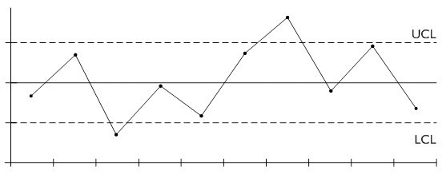

**Scatter chart:** used to find correlation between two variables

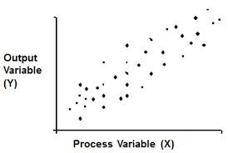

**Gantt chart:** shows scheduled activities over time, often including dependencies & relationships

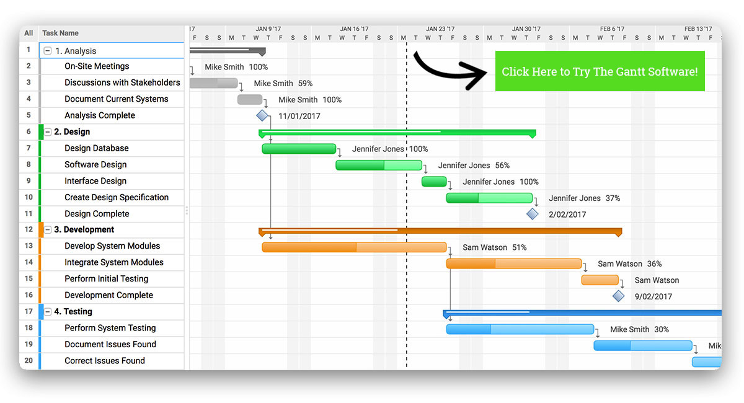

**SWOT Analysis:** used during the Planning phase to ID project risks

Strengths

Weaknesses

Opportunities

Threats

**RACI Matrix:** used during the Planning phase to analyze roles & responsibilities

Responsible (R):

Accountable (A):

Consulted (C):

Informed (I):

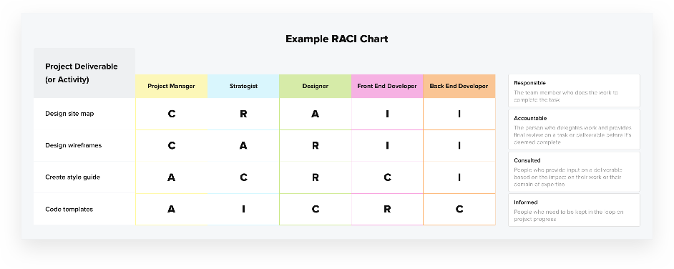

**Purchasing Documents:**

RFI (Request for Information): used when the project knows it goals but not exactly what is needed to get there

RFP (Request for Proposal): project knows some of their requirements

RFQ (Request for Quote): project knows exactly what they need, just asking for a quote

**Contract types:**

Firm Fixed Price (FFP): price is set at outset, cannot change unless the scope changes. Risk is to the vendor.

Fixed Price Incentive Fee (FPIF): same as above, but includes vendor incentive

Fixed Price-Economic Price Adjustment (FP-EPA): adjusts price based on a specific financial index

Cost Plus Fixed Fee (CPFF): vendor is paid all costs plus a fixed fee, normally a % of estimated costs

Cost Plus Incentive Fee (CPIF): vendor is paid all costs plus an inventive fee

Cost Plus Award Fee (CPAF): vendor is paid for all allowed costs, award fee based on performance

Time & Materials (T&M): open-ended, payment based on billable time plus all allowed costs

**More Contract types:**

Non-Disclosure Agreement (NDA): ensures confidentiality

Cease & Desist: legal document serving as formal notice

Letter of Intent (LOI): normally a precursor to a formal contract

Statement of Work (SOW): gives a description of the procurement item

Service Level Agreement (SLA): sets metrics for a service

Purchase Order (PO): states the financial agreement, terms, delivery method, date, etc

Warranty: provides an assurance of quality

**Project Management Plan key components:**

* Scope statement
* Project schedule
* Communication plan
* Resource plan
* Procurement plan
* Project budget
* Quality management plan
* Risk management plan

(The Project Management Plan is also likely to include the WBS.)